Thesis proposal
Identifying anomalies on Vietnam's Roads using traffic camera

Introduction
Vietnam, especially its busy cities, has ongoing traffic problems. These include daily traffic jams that increase business costs and affect people's lives, as well as frequent traffic accidents that result in thousands of deaths each year.
While real-time traffic monitoring offers immediate intervention, the sheer volume and complexity of traffic data make it impossible for human operators to identify every crucial event.
This is where anomaly detection in traffic camera footage becomes a critical enabler. By automatically pinpointing unusual patterns – from subtle shifts in traffic flow indicating emerging bottlenecks, to sudden vehicle stops or erratic maneuvers signaling potential accidents, or even instances of habitual rule violations – anomaly detection transforms passive surveillance into proactive intelligence. This capability not only supports rapid emergency response and real-time traffic management but, crucially, provides invaluable historical insights for urban planners and policymakers to identify underlying issues, optimize infrastructure, and ultimately build safer, more efficient, and more sustainable transportation systems across the country.
To address these challenges, this research proposes the use of revised state-of-the-art (SOTA) deep learning models tailored to the specific context of Vietnam's traffic conditions

Problem description
The challenge lies in the ability to automatically detect anomalies within traffic camera footage. However, anomalies can be defined differently in different scenarios:
Contextual Anomalies: A pedestrian walking on a highway is an anomaly, whereas walking on a roadside is normal. Similarly, a vehicle stopping abruptly in the middle of a busy intersection is unexpected, but stopping at a red light is routine.
Temporal Anomalies: Traffic patterns that deviate from the usual flow at specific times of the day can indicate emerging congestion or bottlenecks. For instance, heavy traffic during off-peak hours might signal an accident or roadblock.
Behavioral Anomalies: Erratic driving behaviors, such as sudden lane changes, speeding, or running red lights, can indicate potential accidents or rule violations.
Thus, the proposed solution shall indicate such anomaly patterns from traffic videos.

Literature review and related works

Benchmark datasets
Dataset Name | Year | # Videos | Length | Example anomalies | Frames Per. Video
Subway Entrance Gate | 2008 | 1 | 1.5 hrs | Wrong direction, No payment | 121,749
Subway Exit Gate | 2008 | 1 | 1.5 hrs | Wrong direction, No payment | 64,901
UCSD Ped1 | 2010 | 70 | 5 min |  | 201
  Bikers, small carts,
  walking across walkways,
  wheelchair users
UCSD Ped2 | 2010 | 28 | 5 min |  | 163
  Bikers, small carts,
  walking across walkways,
  wheelchair users
CUHK Avenue | 2013 | 37 | 30 min |  | 839
  Strange action,
  Wrong direction,
  Abnormal object
ShanghaiTech Campus Dataset | 2017 | 437 | 3.67 hrs |  | 1,040
  Running, Loitering,
  Biking in Restricted Areas,
  Unusual Gatherings, Theft
UCF-Crime | 2018 | 1,900 | 128 hrs |  | 7,247
  Abuse, arrest, arson,
  assault, accident, burglary,
  fighting, robbery
XD-Violence | 2020 | 4,754 | 214 hrs |  | 3,944
  Abuse, Car Accident,
  Explosion, Fighting,
  Riot, Shooting
NWPU Campus dataset | 2023 | 547 | 16 hrs |  | 2,527
  Single-person, interaction,
  group, location,
  appearance, trajectory

Training paradigms and related researches

Supervised learning
In supervised learning, algorithms are trained on datasets where frames are pre-classified as either ’normal’ or ’anomalous.’, or even what is the anomalous type. However, supervised methods are less common due to the scarcity of datasets with detailed annotations at the frame level for the training set.
Supervised Anomaly Detection via Conditional Generative Adversarial Network and Ensemble Active Learning (cGAN-EAL) (https://arxiv.org/pdf/2104.11952)( Zhi Chen, et, al, 2021)
The Authors introduce a new method for detecting anomalies using a supervised approach. It tackles the challenge of detecting rare occurrences and dealing with imbalanced datasets where normal instances significantly outnumber anomalies.
The core of the method is the Ensemble Active Learning Generative Adversarial Network (EAL-GAN). This is a conditional GAN, however, it has one generator and multiple discriminators. This structure is unusual for GANs, which typically have a single discriminator. The anomaly detection happens within an auxiliary classifier attached to the discriminator.
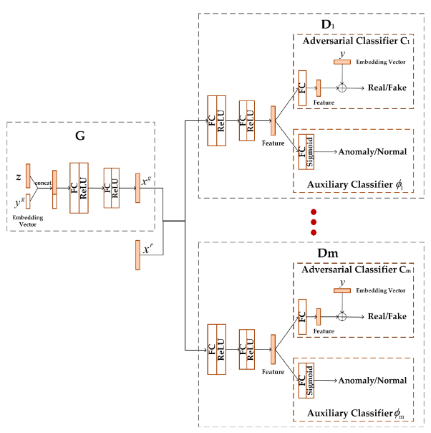
The paper addresses the issue of imbalanced datasets through three mechanisms:
- Synthetic Data Generation: The conditional GAN generates synthetic anomaly examples, supplementing the limited number of real anomaly instances available for training. This helps balance the dataset and prevents the model from being biased toward normal data.
- Ensemble Learning Loss: A special loss function encourages the multiple discriminators to "cover for each other's weaknesses.". This helps ensure that the model learns a robust representation of both normal and anomalous data, further mitigating the class imbalance problem.
- Active Learning: The method incorporates active learning. This means the model strategically selects which data points to be labeled by a human expert, optimizing the learning process and reducing the cost of labeling, which can be expensive and time-consuming. According to the authors, EAL-GAN can provide state-of-the-art performance by only labeling 5% of the real data in each batch.
Analysis:
- The model main aims to tackle imbalance labeled data to feed into supervised ensembled Auxiliary Classifier.
- However, as this model only handle image frame as input, without considering temporal features, it is not possible to detect temporal and behavioral anomalies as indicated in Viet Nam traffic.

Self-Supervised learning
In self-supervised approaches, algorithms generate their supervision from the input data, bypassing the need for external labels provided by humans. This paradigm is particularly valuable for anomaly detection, where labeled anomalous data is scarce.
Anomaly Detection in Video via Self-Supervised and Multi-Task Learning (Georgescu, et. al, 2021)( https://arxiv.org/pdf/2011.07491)
The authors devise an object-centric approach comprising a 3D convolutional neural network that jointly learns the following proxy tasks:
- Predicting the arrow of time: the proxy task is expected to predicted the direction of the movement of objects whether it is backward or forward. If it is set to backward, there shall be anomaly.
- Motion irregularity: he intermittent object-centric sequence is created by retaining the frame i, then gradually adding t randomly chosen previous frames and t randomly chosen succeeding frames. The intermittent object-centric sequence is labeled as irregular motion
- Middle bounding box prediction: learns to reconstruct objects detected in the normal training videos.
- Model distillation: learns to predict the features from the last layer (just before softmax) of a pretrained ResNet-50. During distillation, the model learns the predictive behavior of the teachers on normal data. During inference, high prediction discrepancies between student and the YOLOv3 teacher when we encounter an object with unusual appearance or that belongs to an object category not seen during training.
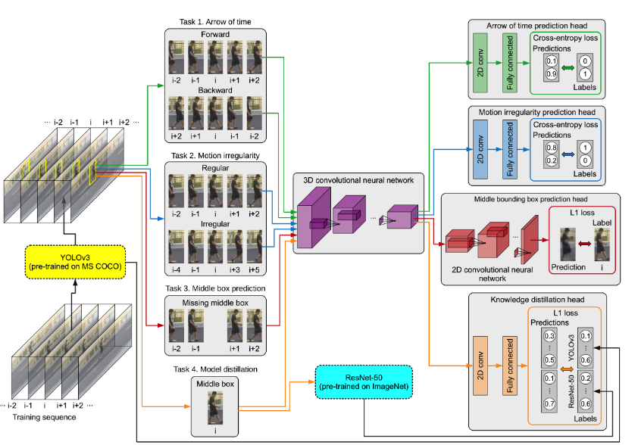
Analysis:
- The authors leverage both spatial (Task 3, 4) and temporal (Task 1, 2) features for anomaly detection. Also, the authors indicate that the downside is that the detection failures of object detection models lead to high false negative.
- However, it is also found that the weight of each task might varies based on dataset which requires further fine tuning. Also, the models leverage multiple heads 3D convolutional neural network which leads to high computational cost.

Unsupervised learning
The unsupervised approaches for video anomaly detection operate under the principle that normal events can be effectively reconstructed or predicted from a learned representation while anomalies or abnormal events deviate significantly from this representation and hence are harder to reconstruct or predict.
These methods are particularly suitable when labeled anomaly data is scarce. During training, only normal videos are considered, while during testing, the model is evaluated on both normal and abnormal videos to assess its anomaly detection capabilities.
Anomaly Detection in Video Sequence with Appearance-Motion Correspondence (Trong-Nguyen Nguyen, 2019, https://arxiv.org/pdf/1908.06351)
The model includes two processing streams:
- The first one is per- formed via a Conv-AE to learn common appearance spatial structures in normal events.
- The second stream is to deter- mine an association between each input pattern and its corresponding motion represented by an optical. The skip connections in U-Net directly transforms low-level features from original domains to the decoded ones. This connections are not employed in the appearance stream because the network may let the input information go through these connections instead of emphasizing underlying attributes via the bottleneck.
- Lastly, the features in both stream is fed to a cGAN discriminator for final decision of anomaly score from each stream.
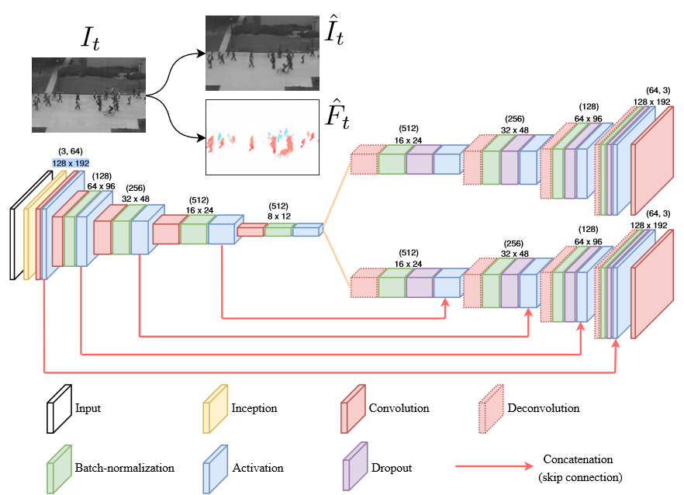
Analysis:
- The model applies both spatial and temporal feature to for the anomaly detection task. Due to simple architecture, the interference is straight forward and could achieve good result in benchmark datasets.
- The implementation requires further handling step which was not describe in model pipeline:
  - Instead of end-to-end training and interference, the model requires preprocessing via modified FlowNet model to analyze the optical flow feature. Only then, the input frame and corresponding flow is parsed to the detection model.
  - Furthermore, as per shown in authors’ demo, the appearance (spatial) stream almost does not contribute to the final decision. This could be due to the spatial branch become too good at generalizing the reconstruction objects.

Reference research
To overcome the above issues, recent studies propose system detects unusual events in videos by memorizing normal activity patterns and predicting future frames. This means instead of only based on input as test frames, the models leverage a memory component to “remember” training features. These features will then applied to re-construct/ predict the new frames, minimizing the effect of over generalization of previous models.
Amongst these, Sunghyun Ahn et. al, (2024, https://arxiv.org/abs/2409.16225) proposed VideoPatchCore, where normal frames’ stored features are utilized for frame reconstruction, identifying an abnormality when a significant difference exists between the reconstructed and input frames.

Main concept
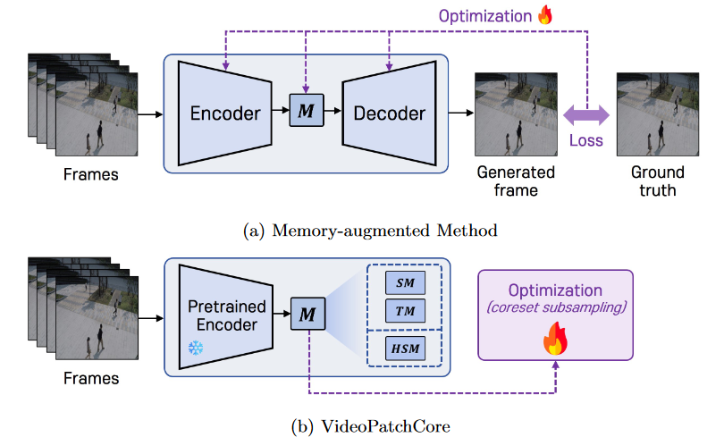
The authors firstly indicate the difficulties of Memory-augmented Methods, which are:
- The simultaneous optimization of the model and memory makes the optimization process difficult and the implementation complex
- The size of the memory significantly impacts performance
To address these issues, the authors proposed the VPC model which consisting of two streams: the local stream at the object level and the global stream at the frame level.
Each stream extracts features through a vision encoder, which pre-trained on large-scale datasets, and these features are segmented according to the type of memory and accessed in the memory bank. During this process, the memorization and inference stages are performed.
In the memorization stage, features are stored in memory, which is then optimized using greedy coreset subsampling.
In the inference stage, anomaly scores are derived by calculating distances between memory and features.
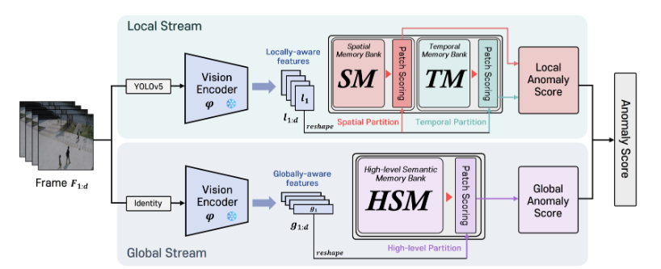

Unlike traditional training paradigm, the model does not required backpropagation to adapt the model to the dataset. Instead, the input frames are converted to latent space and stored in different memory banks using pretrained models. The research then focuses on how to sample the memory bank to reduce the size.
During interference phase, the model also converts the test frames to latent space and find distance to stored features. If the distance is large, then the frame is identified as anomaly.
The patch partion method can be described as below:
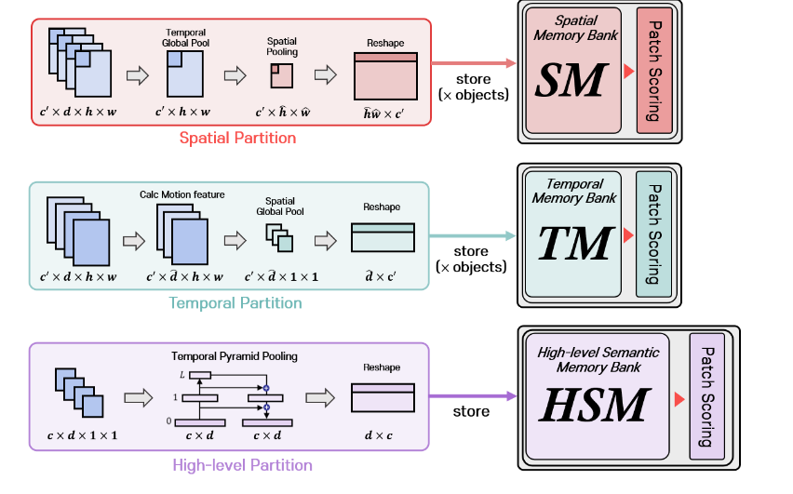
- The spatial partition focuses on object appearance information, generating patches while disregarding temporal information.
- The temporal partition emphasizes object motion information, generating patches while ignoring spatial information.
- The high-level partition utilizes extensive spatiotemporal information to generate patches for understanding the contextual information across frames.

Greedy Coreset subsampling
A Coreset is a small, weighted subset of the original input set of items, such that solving the problem on the coreset will yield the same solution as solving the problem on the original big data.
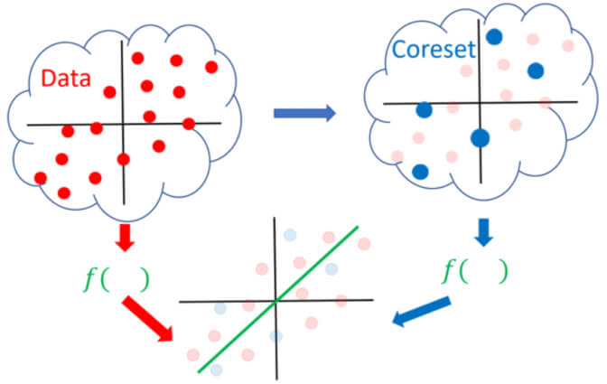
A coreset for an input data approximates the loss with respect to any query the optimal one.

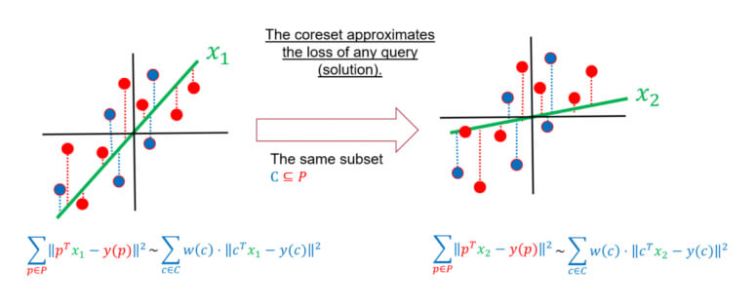
Greedy coreset sampling method iteratively selects points that are farthest from the already selected centers, ensuring that the selected subset of points (coreset) is representative of the entire dataset. This approach helps in reducing the dataset size while maintaining its diversity.

Metrics
The ROC curve gives a visual representation of the trade-offs between the true positive rate (TPR) and false positive rate (FPR) at various thresholds. It provides insights into how well the model can balance the trade-offs between detecting positive instances and avoiding false positives across different thresholds. AUC, or Area Under the Curve, is a single scalar value ranging from 0 to 1, that gives a performance snapshot of the model.
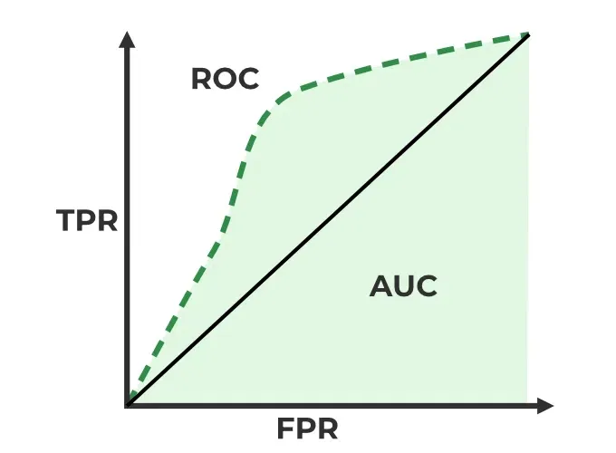

Evaluation on benchmark datasets:
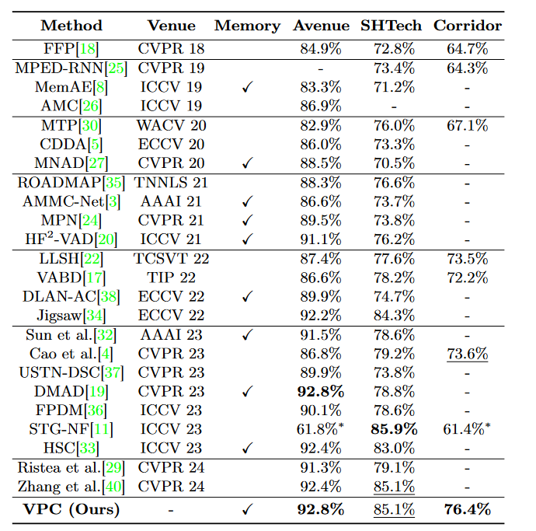

Further evaluation on subset sampling ratio:
The study shows that using Coreset subsampling, the performance difference in memory usage between 1% and 99% is very minimal, less than 0.5%, and the frames per second (FPS) can be up to 7.3 times faster. This demonstrates the effectiveness of coreset subsampling in large datasets such as SHTech and Corridor.

Objective of the thesis:
- Gain comprehensive understanding of anomaly detection strategies.
- Adapt SOTA strategy to Viet Nam situation.
- Provide a suitable dataset for Viet Nam traffic anomaly detection.
- Identify suitable benchmark for evaluation

Scope of the thesis:
The thesis primarily concentrates on techniques to detect anomaly in Viet Nam traffic
Data collection:
- Use government channels to collect traffic data: https://www.youtube.com/watch?v=xCNRP131kNY
- Self-label the data as one class classification
- The data format shall be:
── testing
└── frames
└── 01
├── 0000.jpg
├── ...
└── xxx.jpg
├── 02
├── ...
└── xxx
└── training
└── frames
├── 01
├── 0000.jpg
├── ...
└── xxx.jpg
├── 02
├── ...
└── xxx
- Each test frame will be labeled as 0 for normal, and 1 for anomaly
Adapt the SOTA model to work with proposed dataset, validate on benchmark criteria (ROC, AUC, AUROC)
Deploy a pipeline to collect real-time data, feed to the model and prediction on anomaly status.

Data Crawling with asynchronous operations
The video is a permanent stream on Youtube, which is not able to be directly download. Therefore, an interface shall be developed to retrieve the stream. It's first important to understand that streaming videos are not hosted as a single file but broken up into many of small files that are continuously downloaded. Therefore, a simple sampling method form a web page shall not works as at different moment, the streamline leads to different chunks.
Furthermore, the process of connecting, showing and recording the stream take much time. This leads to the recorded frames are discrete and delayed. Therefore, the concept of asynchronous operation is applied to tackle the issue:
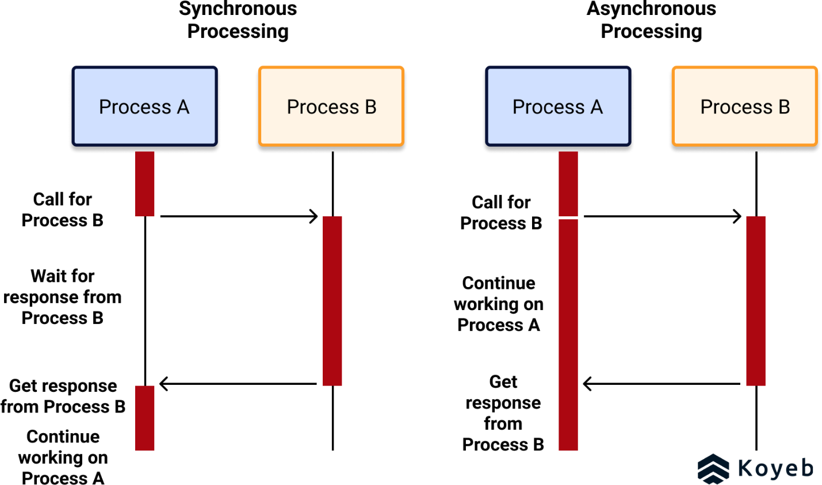
- Network Operations: Fetching the stream URL and reading video frames are I/O bound tasks. Using async coding helps in efficiently managing these operations without blocking the main thread.
- Reconnection Attempts: handle reconnection attempts if the stream fails. Using async coding allows the program to sleep and retry without blocking other operations.

